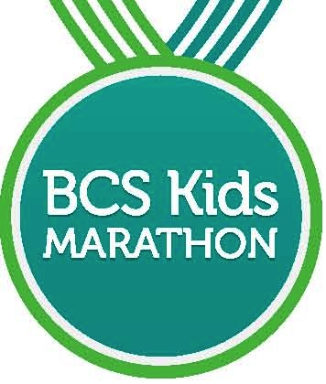
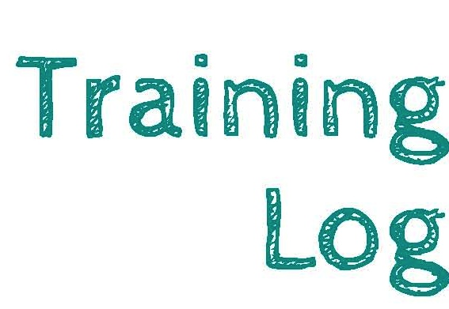

December 13, 2014

BCS Marathon Kids, this is your training log for tracking your miles as you get ready for the Kid’s Marathon on December 13, 2014. It would be fun if you ran 25 miles between now and your marathon so that when you finish the race your total will be about 26.2 miles. That would be the same distance that the grown up racers will run in the Baylor Scott & White BCS Marathon on the next day. We know you can do it too! Ask your parents to help you remember your miles and keep running to have fun!

Your Name: Age on December 14:

Favorite Place to Run:

Run Date Run Distance Run Date Run Distance

