Good morning from FOB Lindsey in sunny Afghanistan. On December 6th at 0800 we lined up for the start of our partner run with the BCS Half marathon. It was a beautiful cool morning here so we had perfect run weather. We had 53 people complete the run including US Army, US Air Force, Australian Army, Bulgarian Army, and African civilian participants. Many of the participants were part of the 205th Coalition Advisory Team. Our job is to mentor the Afghan soldiers in the 205 Corps of the Afghan Army in order to help them along the way to independence. Other participants still conduct combat missions and patrols. This is the reason everyone who signed up did not end up running. Sometimes you get assigned a mission at the last second. That of course has to take priority.

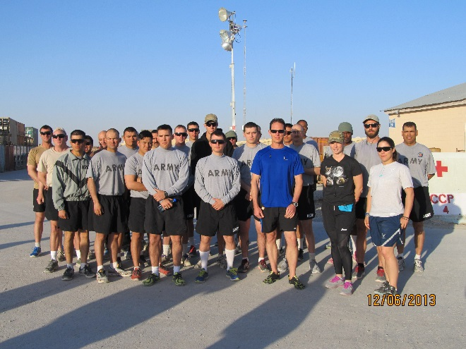

Some our runners on 6 December

We have a small area here so the run is a figure eight around base. This race was ten times around the course. Not the most interesting of tracks but no one seems to mind too much. As always we had volunteers to provide direction to the runners, deliver first aide (running on gravel is murder on your ankles), hand out water, and of course take pictures. Just like back home we couldn’t put on these runs without our volunteers.

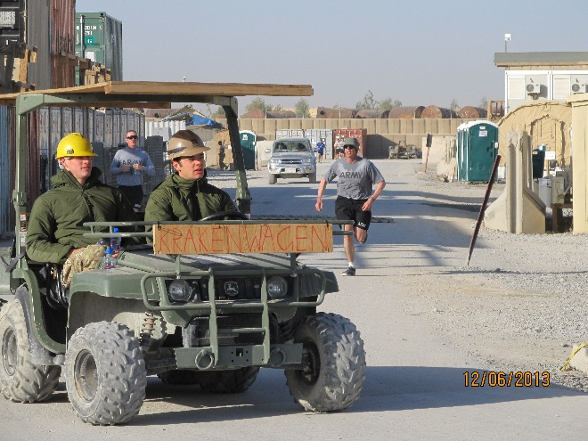

Some of our volunteers

Some of our runners were very fast. Our winner finished in 1 hour 23 minutes. Unlike the last race we did, the official timing system, also known as my iPad, worked the whole time. We had some really fast runners, some first time half marathoners, and everything in between.

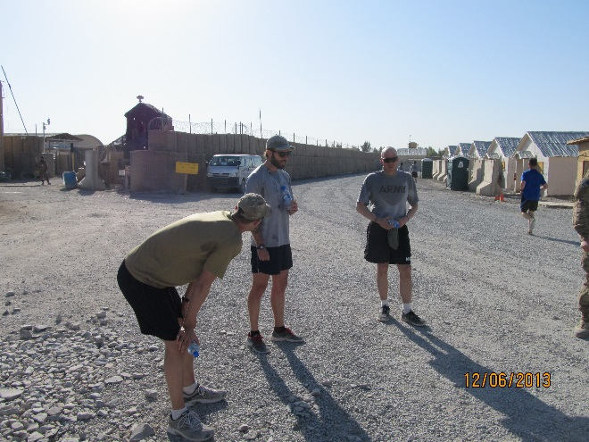

The top three finishers

Most importantly, everyone finished and we had a really good time. These partner runs are great for morale and break up the monotony of the deployment. We can’t wait to see our finisher medals and t-shirts. Needless to say everyone was a bit disappointed we couldn’t join in the post- game celebrations at the run back home. We had to settle for lunch in the chow hall.

Here are some more candid shots from the run (a bit different scenery than back home).

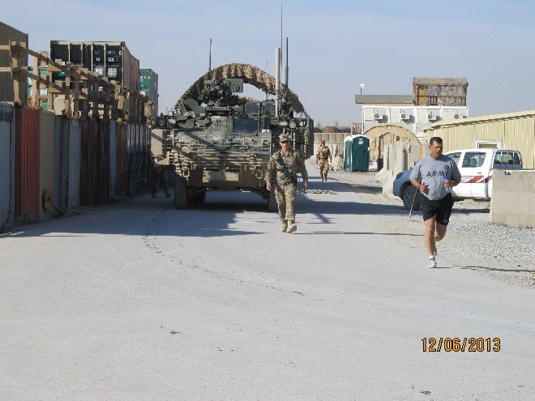

Some of the unique scenery we run with over here

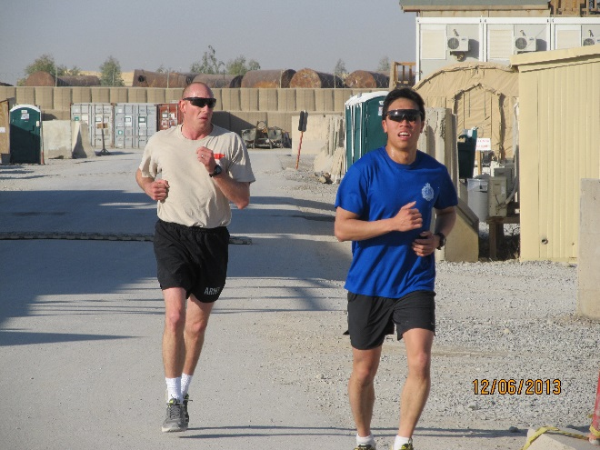

US and AUS participants

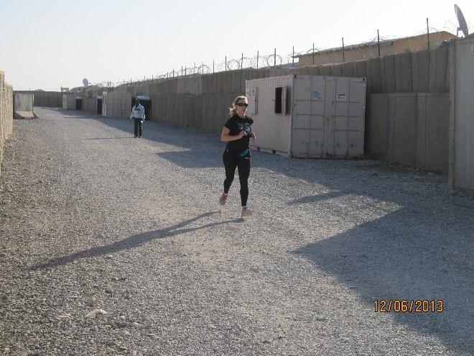

Representing the girls!

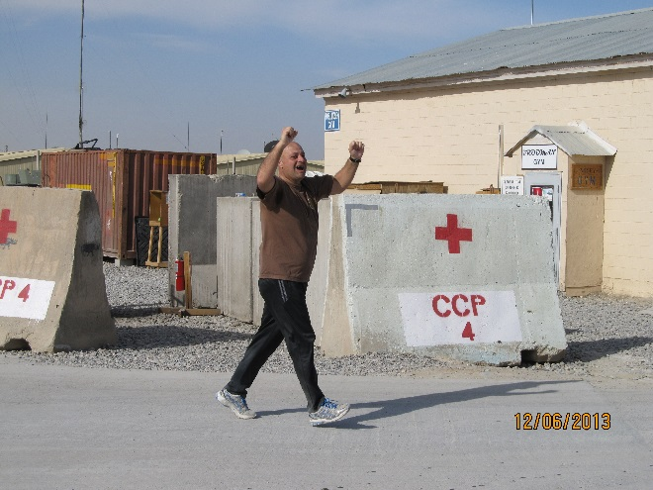

One of our first time half marathoners from Bulgaria

We had a great time. A huge thanks again to Jared and everyone at the BCS Marathon organization for making this happen!!!

Robin